Chapter 6 Functions of Random Variables

* 6.3 The Method of Distribution Functions

This method is typically used when the Y’s have continuous distributions.

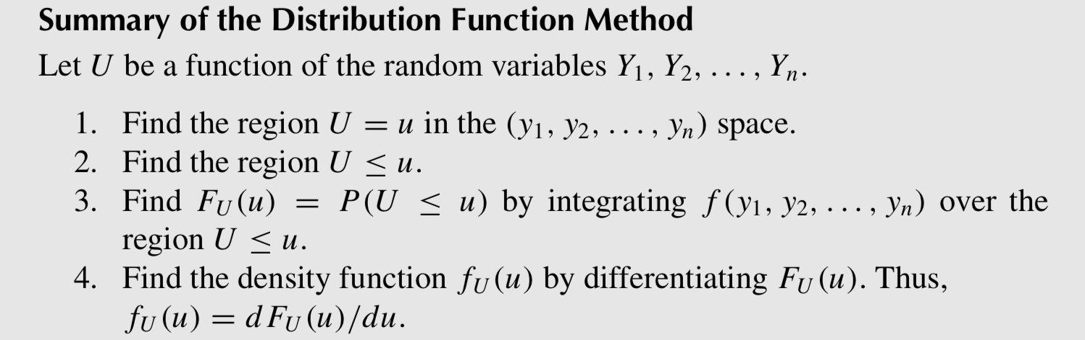

* 6.4 The Method of Transformation

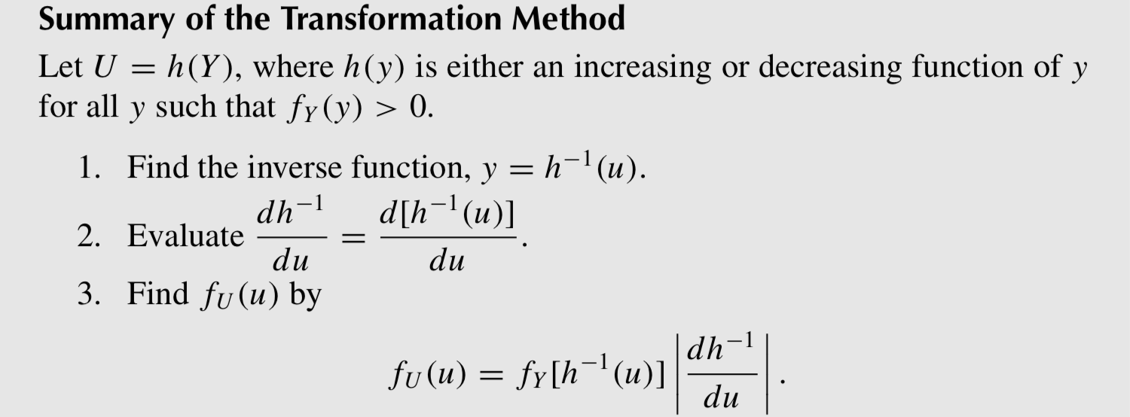

* 6.5 The Method of Moment-Generating Functions

<Uniqueness Theorem>

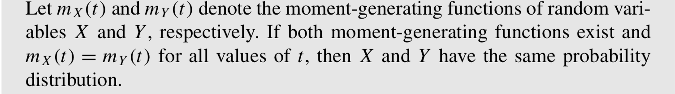

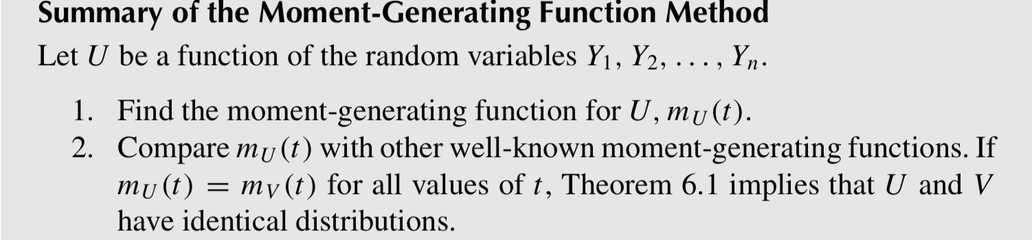

= E(etU )

<Theorem 2> useful for finding the distributions of sums of independent variables

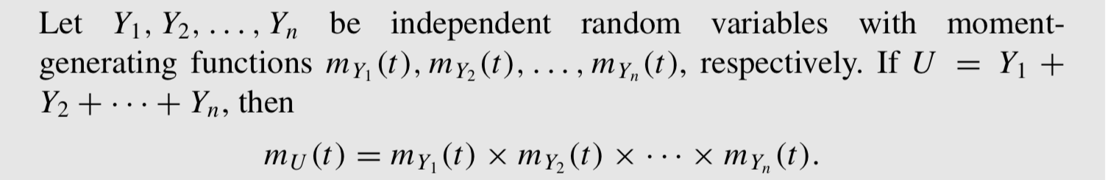

<Theorem 3> useful for functions of normally distributed random variables

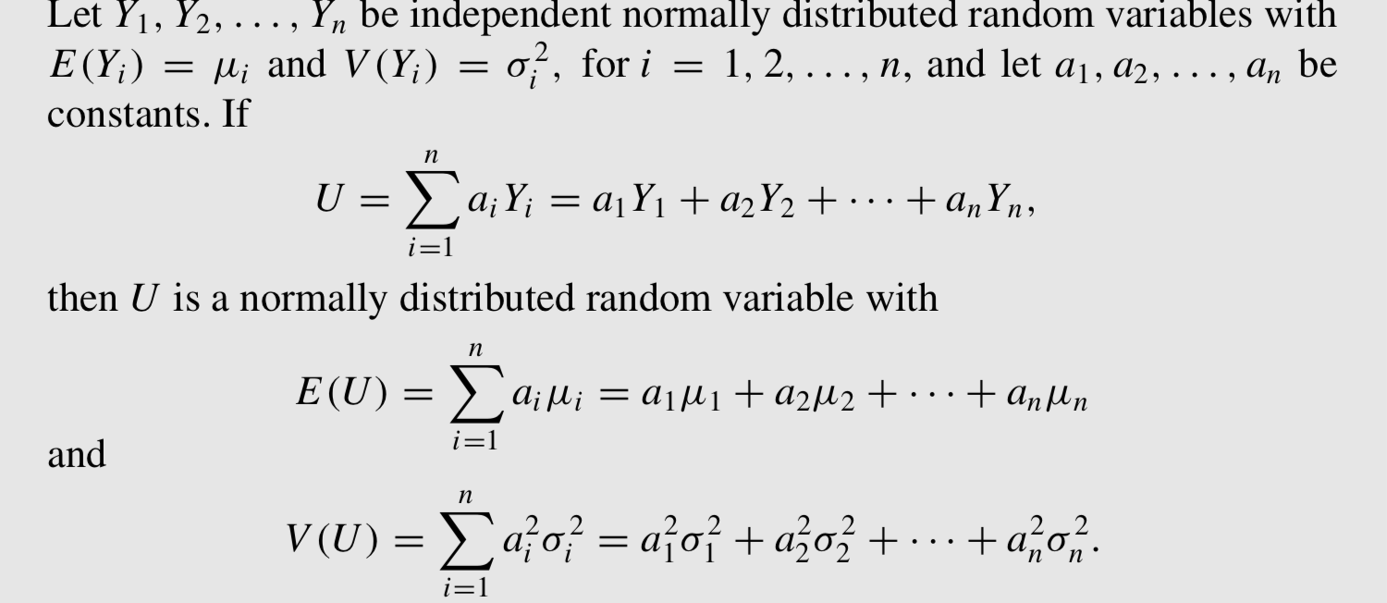

<Theorem 4>

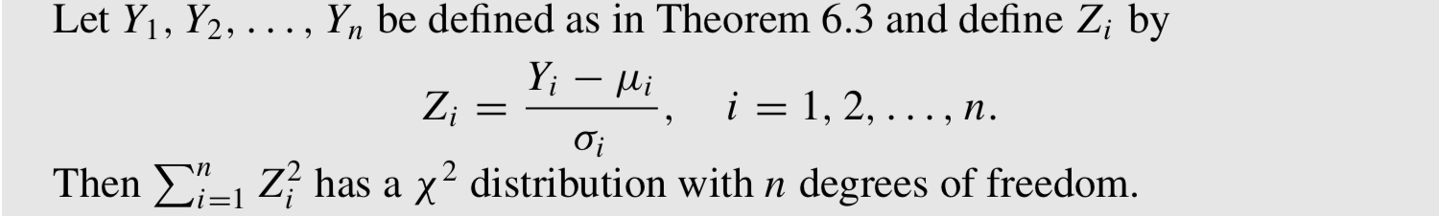

* 6.6 Multivariable Transformations Using Jacobians

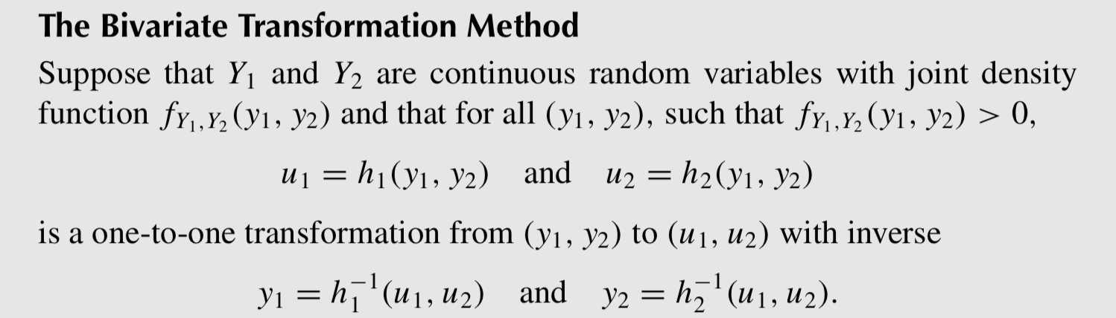

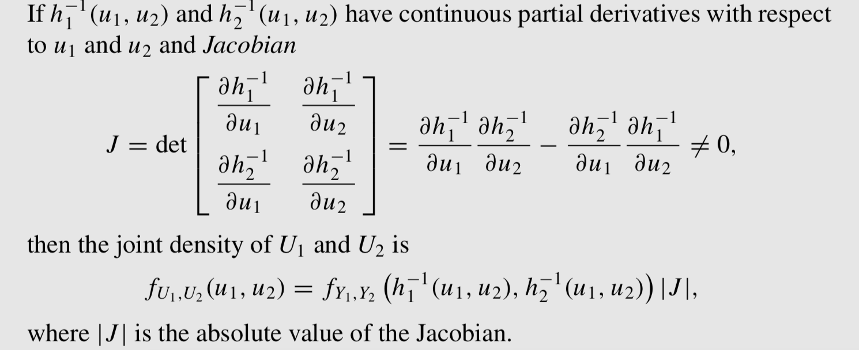

* 6.7 Order Statistics

Formally,letY1,Y2,...,Yn denote independent continuousrandomvariableswith distribution function F(y) and density function f (y). We denote the ordered random variables Yi by Y(1), Y(2), . . . , Y(n), where Y(1) ≤ Y(2) ≤ · · · ≤ Y(n). (Because the ran- dom variables are continuous, the equality signs can be ignored.) Using this notation,

Y(1) = min(Y1,Y2,...,Yn) is the minimum of the random variables Yi , and

Y(n) = max(Y1,Y2,...,Yn)